Data Visualisation 1 Report

Albert Chow, 29694523  
Wednesday 11am Studio 02  
Tutor: Joe Liu

Link: <https://public.tableau.com/app/profile/albert.chow3694/viz/HigherEducationinAustralia/Dashboard1>

Word count:

# Domain

The domain of my visualisation is higher education. It explores different statistics around enrolments in higher education in Australia, specifically pertaining to the makeup of the cohort in terms of gender, field of study and citizenship.

# Why? And Who?

To communicate to the average Australian what the state of higher education looks like in Australia, particularly the demographics of certain cohorts.

# What?

I have used 2 datasets available under the Australian Government Department of Education website:

* <https://www.dese.gov.au/higher-education-statistics/resources/student-enrolments-pivot-table>
* <https://www.dese.gov.au/higher-education-statistics/resources/2020-student-summary-time-series>

The data has been collected from higher education institutions and aggregated to be published in a human readable format for the public.

I have further processed using a combination of Excel and Python scripts to return it to a machine readable format for Tableau to read.

Why and How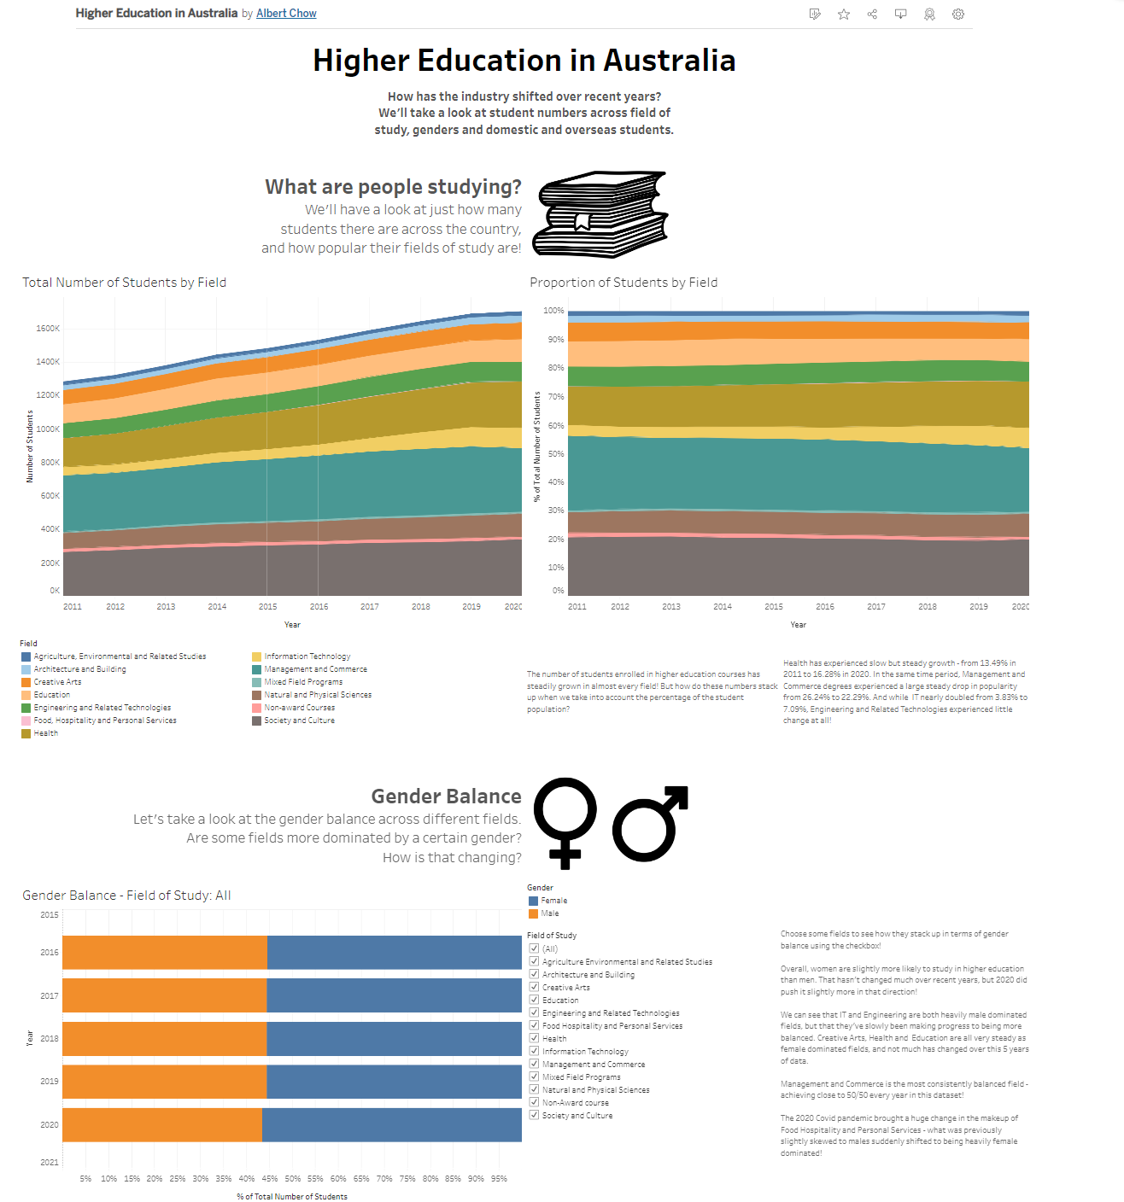

I have chosen very simple idioms for my visualisation – namely area and bar charts. This is because they are simple to interpret, and don’t encode any superfluous information.

The bar chart for the gender balance makes it very clear what the gender balance is and how it changes over the years, even if the changes are small amounts. I chose a bar chart instead of an area chart so that it was easier to see the values against the tick/grid. I also chose it to be horizontal rather than vertical so that the small differences from year to year would be more visible.

The area charts for field of study were chosen to clearly communicate a) the total amount of students and b) a normalised breakdown of the proportion of students. I felt that it was difficult to understand changes in popularity of certain courses by only including the total number of students, so additionally showing the proportion remedied that problem.

# Design

### Layout

I structured my visualisation into 4 sections: title, field, gender balance and citizenship. Each of these sections occupied its own separate space, taking up the full width of the visualisation and a section of vertical space.

Within the latter 3 sections, I applied a consistent set of vertical sightlines, dividing each section horizontally into quarters. Each figure took up 2 quarters, and any legends/filters/text each took up 1 quarter. When I needed additional space in the field section, I simply shifted the legend and additional text down below the figures and split them across the quarters.

### Colour

I did not elaborately use much colour in my visualisation – I kept it simple to reduce chartjunk. I simply assigned a number of colours to the field visualisations and ensured that similar colours were separated from each other, and that red and green were not both present to ensure colour-blind people could still read it.

I kept a consistent colour scheme of blue and orange for the other two figures, as they are contrasting colours (and therefore easy to read), and using the same colours for the separate figures made the colour scheming more cohesive than changing the colour scheme between them.

### Figure-ground and Typography

I used the size of text to impose a hierarchy to ensure the most important text was read first. The title/subtitle deliberately break the sightlines imposed on the rest of the visualisation to ensure that the reader is immediately drawn to them.

The whitespace between sections serves to indicate to the reader that the upcoming information is separate to what we’ve previously seen, and the use of an image at the top of each section quickly indicates to the user what the section will be about before they even read the section title.

### Storytelling

In conjunction with the layout, the user is guided into reading top to bottom and left to right, since the visualisation is quite vertically long. The user reads from the top and progresses through the sections, and then their attention is caught by the figures which are put on the left. Then they will progress to the more cognitively demanding text, which is positioned next to the figure.

# Bibliography

### Datasets:

Australian Government Department of Education and Training. 2022. *Student Enrolments Pivot Table*. [online] Available at: <https://www.dese.gov.au/higher-education-statistics/resources/student-enrolments-pivot-table> [Accessed 1 September 2022].

Australian Government Department of Education and Training. 2022. *2020 Student summary time series*. [online] Available at: <https://www.dese.gov.au/higher-education-statistics/resources/2020-student-summary-time-series> [Accessed 1 September 2022].

### Images:

Commons.wikimedia.org. 2022. *File:Gender symbols side by side solid.svg - Wikimedia Commons*. [online] Available at: <https://commons.wikimedia.org/wiki/File:Gender_symbols_side_by_side_solid.svg> [Accessed 5 September 2022].

Gandy, D., 2022. *File:Globe font awesome.svg - Wikimedia Commons*. [online] Commons.wikimedia.org. Available at: <https://commons.wikimedia.org/wiki/File:Globe_font_awesome.svg> [Accessed 5 September 2022].

Kücklich, J., 2022. *File:Bücher.png - Wikimedia Commons*. [online] Commons.wikimedia.org. Available at: <https://commons.wikimedia.org/wiki/File:B%C3%BCcher.png> [Accessed 5 September 2022].